SILTA records

PRESS RELEASE – 30.08.2006

Silta Records is pleased and honoured to announce this new CD: “Night Dancers” by Paolo Lattanzi Group.

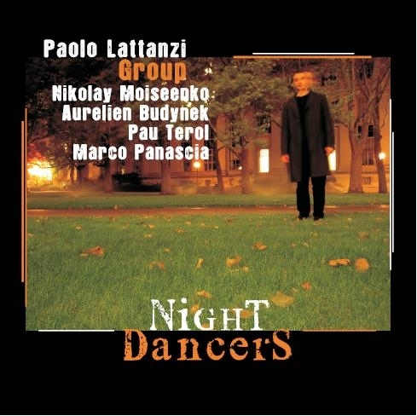

This is a job of high artistic quality, fully made in the US, where the musicians of the Band (of different nationalities) live and work.

Paolo Lattanzi, drummer and Bandleader of the quintet, shows with elegance all his capability as refined musician in a well balanced repertory. Not many words are necessary to explain the value of this project, as already from the first notes we realize the high professional level of the five elements, leaded by the expert Paolo lattanzi which is also composer and arranger of all this music.

For Silta Records this is a confirmation of the attitude to bring value to the artistic talent of fine musicians, an excursion into tonal Jazz, which shows how it is possible to perform valuable and original Jazz Music, with no need to emulate the Great jazzmen of the past but following their path.

This is not music to be played as background entertainment at a party! This is music to be listened to, with all your attention. It’s jazz music that changes moods as it progresses from one moment to the next. It is contemporary in its melodic, harmonic, and rhythmic components but it clearly proclaims its allegiance to the jazz tradition. I am impressed with the way the individual talents of the five musicians are blended together to create a group sound as they complete the journey of each of the tunes. They listen to each other and each episode follows in organic continuity with the one before it, whether it be phrase to phrase or from soloist to soloist. Nikolay Moiseenko (saxes) and Aurelien Budynek (guitars) are an exhilarating “front line” whose unison melodies and individual improvisations are played with precision and sensitivity. Pau Terol (Piano) and Marco Panascia (bass) are also great improvisers and provide a consistent and energetic comping foundation throughout the CD. Paolo Lattanzi, the composer of these tunes, provides a unique time ride accompaniment as the drummer. I always enjoy it when a drummer plays the composition and not just generic time. Being the composer, Paolo knows what he wants and what rhythmic color choices will best support his melodic/harmonic ideas and he delivers the drum part with inspired confidence.

This is an exciting first effort from these talented musicians. Whether you like dark introspective modality, a lyric ballad, or flying fingers “burn”, just sit back and enjoy. Like me, I think you’ll find that these “Night Dancers” can dance with the best of them.

Ken Pullig
Direttore, Jazz Composition
Berklee College of Music
Boston, Ma
USA

For information and request to interview:
www.siltarecords.it
info@siltarecords.it

